Yizhe Ge | yge43@wisc.edu

Haoyang Yan | hyan92@wisc.edu

Kyungjin Cho | kcho36@wisc.edu

Sungrim Lee | sungrim.lee@wisc.edu

Jianzhuo Liu | jliu2245@wisc.edu

**Preliminary Report**

*Part1. Introduction and Question Refinement*

These days, the majority of people believe that the earth is round. Yet, we wonder, what made people have no doubts in believing that the earth is round. One possible reason is that people can easily observe the earth's round-shaped shadow on the moon during the lunar eclipse. Also, by measuring shadow casting from two different cities, the sphere shape of earth can be proved. Such observations are not visible if the earth is flat. Furthermore, the earth images taken by satellite directly gives us the fact that the earth is round. Last but not least, the sun rises and sets from a different time at a different place. This also can not happen given that the earth is flat. In this project, we will prove the last fact since the first three facts are evident to prove that the earth is round; furthermore, those three facts are neither feasible nor suitable to collect the data set for this project.

If the earth is round and we need the proof to show it is, how would we refine it? The question that came to our mind was “**If the earth is round, are we able to predict the sunrise time of different cities?**”. Since there exist other factors derived from the fact that the earth is round, we thought that those factors could explain the sunrise time as well. Hence, we decided to find the factors affecting the sunrise time and predict the sunrise time given the following factors.

*Part2. Basic Theory to Calculate the Sunrise Time*

In this section, we assume that the earth is round and try to find the expectation of our model. In order to compute the expectation of our model, which is the sunrise time, we use 3 important features which are date, latitude and the difference of longitude. Through those, we can calculate the sunrise time and time zone difference by:

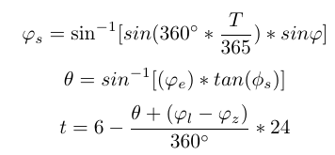

Where, T: number of days from the vernal equinox; $φ_{e}$: latitude of the location; $φ_{l}$: longitude of the location; $φ_{z}$: longitude of the time zone; φ: Obliquity of the Ecliptic, 23.44˚; $φ_{s}$: Sun Declination angle; θ: a given location passes the terminator at same time with someplace on the equator which has a longitude difference of θ; t: sunrise time.

*Part 3. The Design Of Experiment*

Step 1. Data Collection

The first step is that we need to collect the data in order to build the model. We decided to use some data that may have a relationship with the sunrise time such as altitude, latitude, longitude, humidity, and temperature. Through collecting the data of the major cities around the world, we were able to build a model to predict the sunrise time in other places.

Compared with the flat earth theory, if the earth is around, the longitude will have a significant visible impact on the sunrise time. Thus, we decided to build a simple model, which is to use the latitude and longitude as explanatory variables, and sunrise time as a response variable. We then built a simple linear regression model.

Our group chose eleven major cities around the world, and collected the data. This is the first step to fit the model, so we decided to use some simple data. All the cities that we choose are in the northern hemisphere. The data is displayed below.

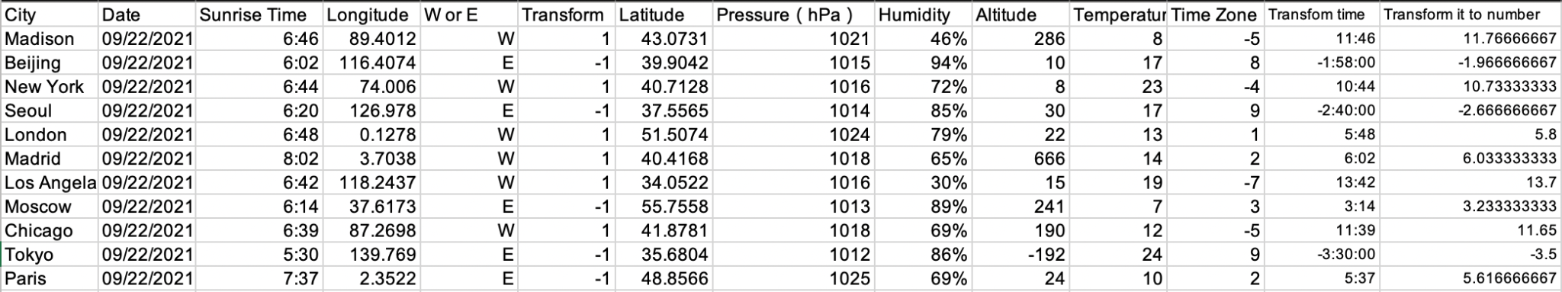

Step 2. Data Formatting

In order to build the model, we had to revise the data to match the given equations.

1. With the influence of east longitude and west longitude, we add a new parameter to help us interpret the data. If it is west longitude, we will use 1 times the longitude. And if it is east longitude, we will use -1 times the longitude.
2. We have to deal with the sunrise time because different cities have different time zones. In order to perform the fit, the time needs to be transformed to GMT +0. Thus, to indicate the time, we used negative times. Then, our group transferred the time into scalar.

Step 3. Build The Model

For the next step, our group input the data into RStudio. We used the linear model to fit the regression. The linear model, the parameter, and the $R^{2}$ and P-value are displayed below.

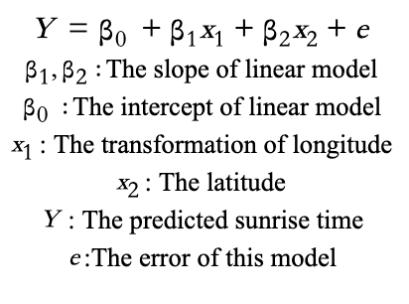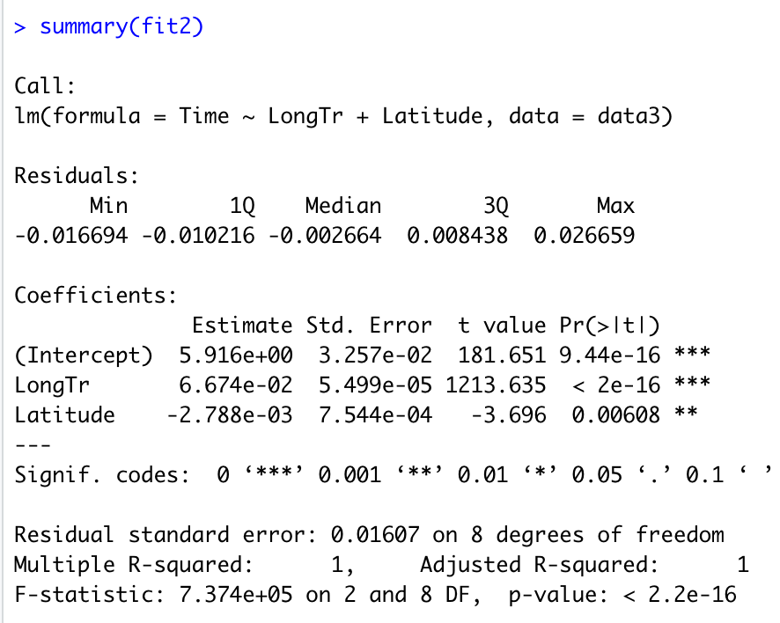

Through the summary of this linear model, we can get the parameter. The longitude and latitude have a clear relationship with the sunrise time. So the next step of our work is to add other factors into it, and try to find their relationship with the sunrise time.

Step 4. Model Verification

We chose Cary’s sunrise time, to check this model. The data of Cary is displayed below.



Through the formula, we can get the transform time of Cary as 11.077, and transform it into a normal form, which is 11:04 because Cary is in the GMT-4 time zone. Then we transform the time back into local time which is 7:04. The result was accurate.

According to our linear regression model, we can now answer the question we refined in the previous page. The answer is clearly explained through our R regression model. Since our $R^{2}=1,$ Our group concludes that the sunrise time across the different cities around the world is able to be calculated through observing the factors such as latitude and longitude. This finding proves that our hypothesis of spherical earth theory is correct.

*Part 4 Shortcomings And Conclusion*

However, this is not the finalized results that our group will be presenting. We believe that there are still some improvements that can be made. One improvement is to collect more sample data to interpret the results. Our group only interpreted the cities in the north hemisphere for accuracy. We believe that this eleven north hemisphere sample data is the least amount of data that we could collect. For the further presentation of our project, we will be using more sample data including the south hemisphere for more accuracy and credibility. Another improvement could be made from the equations that we used. Our equation only implements the use of latitude and longitude as explanatory factors to build the model. Since this equation that we used has $R^{2}$ of 1, we would once again doubt the results and try to work on the equation that implements other factors.

To conclude our preliminary report, we decided to use the sunrise time as the response variable. There are several explanatory variables such as temperature, pressure, altitude, latitude which could affect sun rise time. Yizhe collected datas from 11 cities that are in the northern hemisphere . We then built a simple linear regression model and analyzed the data. We decided to use a 95% confidence interval in this experiment. The p-value of each coefficient and residuals are less than 0.05. By checking the $R^{2}$, we would say that almost 100% percent of the model is explained by our data. Yet since this result is derived from a small sample size of population, we still need some improvements in this experiment for the upcoming weeks.

In the next few weeks, we will build a larger dataset, which includes at least 50 observations since our dataset is not large enough to generalize. We also decided to add more variables to the model. However, there are still some conflicts that our group faces such as the interaction term. The correlation between explanatory variables and interaction terms may be existing and we need to solve this problem in the upcoming weeks.